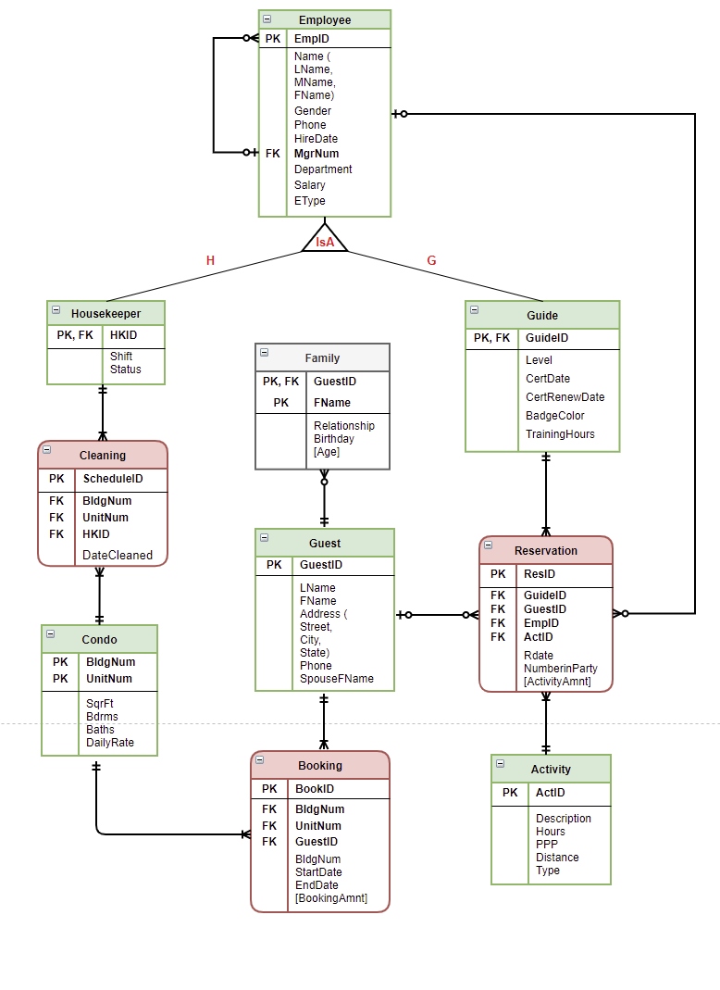
K
J
I
H
G
F
E
D
C
B
A
- Each employee needs to report to one manager except for the CEO (optional one). Each manager manages at least one employ but not all employees are managers (optional many).
- In a Super/Subtype relationship, the primary key (PK) of the subtype also functions as a foreign key (FK), referencing the primary key of the supertype. This principle is applicable to both the Housekeeper and Guide entities.
- In a 1:M relationship, FK is placed on the 'many' side. Therefore, composite attributes (BldgNum and UnitNum) are added to the Cleaning entity, and HKID is added to Cleaning as well. Likewise, Reservation includes four FKs from Guide, Guest, Activity, and Employee.
- Each guest can have many children but some have none (optional many). Each child can only belong to one guest (mandatory one).
- In the Family entity, we need both GuestID and child's Fname to form the unique composite PK. GuestID is the sole FK referencing the PK in Guest.
- Every condo in Famcation has been booked by guests for at least once (mandatory many).
- Every activity in Famcation has been reserved for at least once (mandatory many).
H, I. Each reservation is either made by one employee or by one guest (optional one for G and J).
- A guest can make multiple reservations for different activities during the stay, but some guests don't have any reservation (optional many).
- An employee can make multiple reservations for different activities, but some employees don't have any reservation (optional many).

